**BLOCK TRANSFER**

DATA SEGMENT

SRC DB 01H,02H,03H,04H,05H,06H,07H,08H,09H,10H

DATA ENDS

EXTRA SEGMENT

DEST DB 10 DUP(?)

EXTRA ENDS

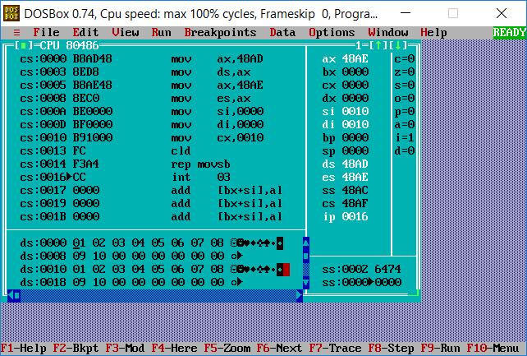

CODE SEGMENT

ASSUME CS:CODE,DS:DATA,ES:EXTRA

START: MOV AX,DATA

MOV DS,AX

MOV AX,EXTRA

MOV ES,AX

LEA SI,SRC

LEA DI,DEST

MOV CX,10H

CLD

REP MOVSB

INT 03H

CODE ENDS

END START

